**NAME: PRAKHAR MISHRA**

**DATE: 22/01/2024**

**QUESTIONS**

1. **Demonstration of Full Join statement.**

**select * from user left join orders on user.userId = orders.userId union select * from user right join orders on user.userId = orders.userId;**

**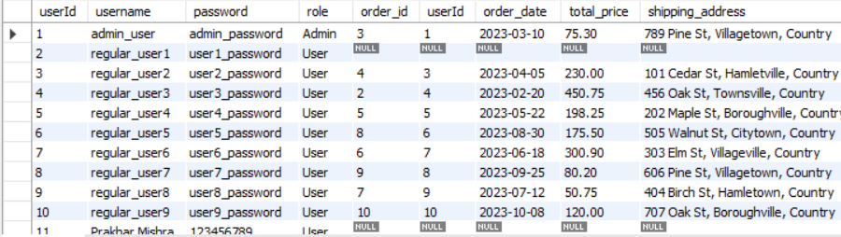  
  
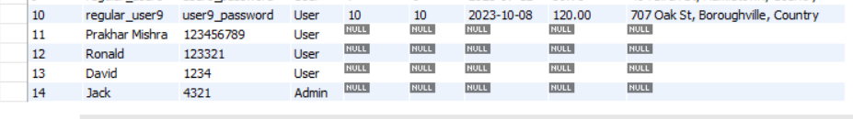**

1. **Demonstration of Equi Join.  
     
   select * from user u, orders o where u.userId = o.userId;**

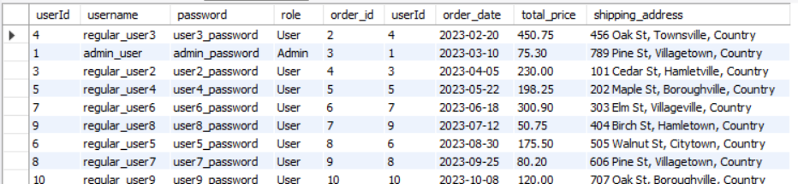

1. **Demonstration of Non-Equi Join.  
     
   select * from user u, orders o where u.userId > o.userId;** 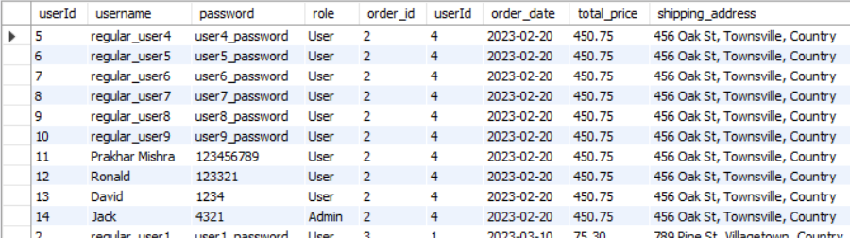
2. **Demonstration of Self Join.**

**elect * from user u1, user u2 where length(u1.username) = length(u2.username);  
  
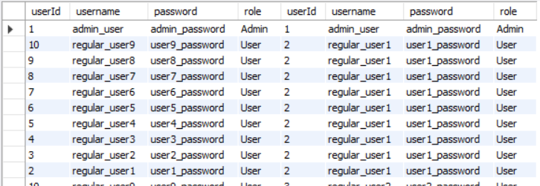**

1. **Demonstration of String Functions.**

**select concat(username, '<+--+--+--+--+>', password) as 'Login Information' from user;**

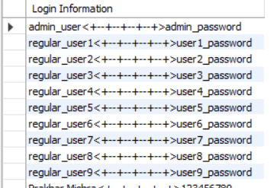

1. **Demonstration of Date Functions.  
     
   select current_date() as today;  
     
   select year(current_date()) as today_date;**
2. **Demonstration of Aggregation Functions.**

**select sum(total_price) from orders;  
  
**

1. **Demonstration of Current User.**

**select current_user() as user;**

1. **Demonstration of Subquery.**

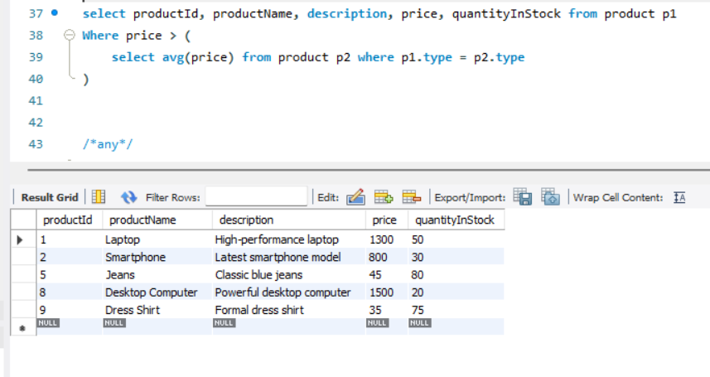

1. **Demonstration of Any.**

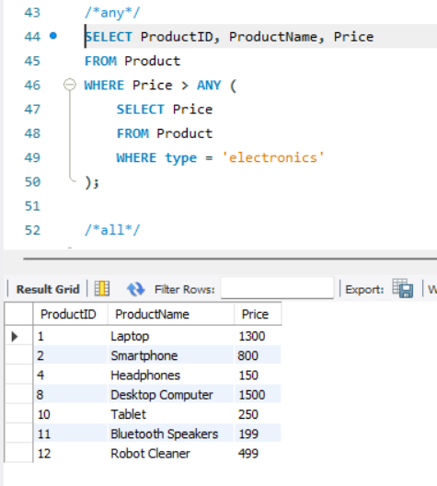

1. **Demonstration of Any;**

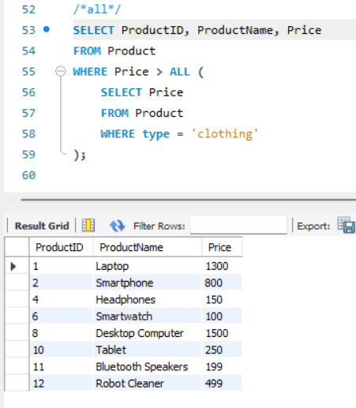

1. **Demonstration of Exists.**

